### Nerve Detection in Ultrasound Imaging Using Deep

### Learning Technique.

Srushti N. Vaidya  
Artificial Intelligence and Data Science  
Faculty of Engineering and Technology, Datta Meghe Institute of Higher Education and Research (Deemed to be University)Wardha, India  
[srushtinvaidya@gmail.com](mailto:srushtinvaidya@gmail.com)

Jay Mehta  
Artificial Intelligence and Data Science  
Faculty of Engineering and Technology, Datta Meghe Institute of Higher Education and Research (Deemed to be University)Wardha, India  
[mehtajay1232@gmail.com](mailto:mehtajay1232@gmail.com)

Hindavi Kakde  
Artificial Intelligence and Data Science  
Faculty of Engineering and Technology, Datta Meghe Institute of Higher Education and Research (Deemed to be University)Wardha, India  
[hindavihk6@gmail.com](mailto:hindavihk6@gmail.com)

Purva Chaudhari  
Artificial Intelligence and Data Science  
Faculty of Engineering and Technology, Datta Meghe Institute of Higher Education and Research (Deemed to be University)Wardha, India  
[purvachaudhari7@gmail.com](mailto:purvachaudhari7@gmail.com)

### *Abstract*

### Nerve segmentation in ultrasound images plays a vital role in diagnosing and managing neurological conditions. However, traditional segmentation techniques, such as thresholding, edge detection, and active contour models, often fail to deliver accurate results due to noise, low contrast, and structural variations in ultrasound images. To address these challenges, this study introduces a deep learning-based approach utilizing a Convolutional Neural Network (CNN) optimized for nerve segmentation. The proposed model leverages automated feature extraction to enhance segmentation accuracy while minimizing manual intervention.Experimental results demonstrate that the model achieves 94.5% accuracy, with a precision of 92.8%, recall of 90.6%, and an F1-score of 91.7%, indicating its reliability in differentiating between affected and unaffected nerve structures. Additionally, the model's AUC-ROC score of 0.97 underscores its effectiveness in handling complex ultrasound imagery. To facilitate practical application, the model is integrated into a web-based diagnostic system, enabling real-time segmentation and clinician-friendly visualization.While the proposed approach significantly enhances segmentation accuracy and efficiency, challenges such as dataset limitations, class imbalance, and real-time processing constraints remain. Future research will explore hybrid deep learning architectures, attention mechanisms, and improved data augmentation strategies to further refine model performance. This study presents a scalable and efficient solution for automated nerve segmentation, contributing to advancements in medical imaging and clinical decision support systems.

***Keywords*-** *Nerve segmentation, deep learning, convolutional neural networks, ultrasound imaging, medical diagnostics, web-based healthcare solutions*

### ***Introduction***

Medical imaging plays a crucial role in modern healthcare, enabling precise diagnosis and treatment planning for various diseases. Among the different imaging modalities, ultrasound imaging is widely used due to its non-invasiveness, cost-effectiveness, and real-time capabilities. However, ultrasound images often suffer from low contrast, high noise, and anatomical variations, making accurate segmentation of nerve structures a challenging task [2]. Effective nerve segmentation is essential for applications such as regional anesthesia, nerve block procedures, and early disease detection. Traditional segmentation approaches, including thresholding, edge detection, and active contour models, have been widely explored but often struggle with variability in image quality and the presence of artifacts [3][4].Recent advancements in machine learning and deep learning have significantly improved medical image analysis, providing automated feature extraction and enhanced segmentation accuracy. Conventional machine learning methods such as Support Vector Machines (SVMs), Random Forests, and K-Nearest Neighbors (KNN) have been applied to nerve segmentation but require extensive feature engineering and lack adaptability to diverse datasets [5][6]. The emergence of deep learning models, particularly Convolutional Neural Networks (CNNs), has transformed medical imaging by enabling hierarchical feature learning, eliminating the need for handcrafted features, and improving segmentation performance [7][8].Among deep learning architectures, U-Net has become a widely adopted model for biomedical image segmentation due to its encoder-decoder structure with skip connections, which preserves spatial information and improves segmentation accuracy [9]. Furthermore, attention-based networks have been introduced to enhance feature selection, allowing the model to focus on relevant anatomical structures while minimizing irrelevant information [10]. Additionally, Generative Adversarial Networks (GANs) have been employed for data augmentation and synthetic image generation, addressing the issue of limited medical datasets and class imbalance in nerve segmentation [11].Despite the success of deep learning in automated nerve segmentation, several challenges remain. Dataset diversity, real-time processing constraints, and the integration of segmentation models into clinical workflows continue to be areas of active research [12][13]. The deployment of deep learning models in web-based diagnostic systems presents a promising solution, enabling real-time segmentation, cloud-based processing, and user-friendly interfaces for clinicians [14][15].This study aims to develop an advanced deep learning-based segmentation model that addresses the limitations of traditional techniques while ensuring high accuracy, efficiency, and clinical applicability. The proposed model is integrated into a web-based platform, facilitating real-time nerve segmentation and improving accessibility for healthcare professionals.

### ***1.1 Importance of Nerve Segmentation in Medical Imaging:***

### Nerve segmentation in medical imaging plays a critical role in regional anesthesia, nerve block procedures, and the diagnosis of neurological disorders. The precise identification of nerve structures is essential to avoid complications during medical interventions and to improve patient outcomes [2]. Accurate segmentation allows clinicians to differentiate between affected and unaffected nerves, which is particularly useful in cases of peripheral neuropathy, nerve injuries, and chronic pain management [3].Ultrasound imaging is widely used for nerve visualization due to its real-time capabilities, cost-effectiveness, and non-invasive nature. However, the inherent challenges of ultrasound images, such as speckle noise, low contrast, and anatomical variations, make manual segmentation difficult and time-consuming [4][5]. Traditional image processing techniques, including edge detection, active contour models, and thresholding, have been explored for nerve segmentation but often fail in complex and noisy ultrasound environments [6].Advancements in artificial intelligence (AI) and deep learning have revolutionized medical image segmentation, enabling automated and highly accurate nerve identification. Deep learning-based models, particularly Convolutional Neural Networks (CNNs), can learn hierarchical image features and adapt to variations in ultrasound images, outperforming conventional methods [7][8]. The integration of AI-driven segmentation into clinical practice can significantly enhance surgical planning, anesthesia administration, and early diagnosis of nerve-related conditions.

### ***1.2 Challenges in Nerve Segmentation***

Despite recent advancements, nerve segmentation in ultrasound imaging faces several technical and practical challenges. One of the primary issues is dataset limitations, as most publicly available datasets are small, homogeneous, and lack diversity in patient demographics and imaging conditions. This results in models that may not generalize well to real-world clinical settings [9][10]. Additionally, class imbalance poses a significant problem, as affected nerve cases are often underrepresented, leading to biased model predictions [11].Another critical challenge is the presence of noise and artifacts in ultrasound images, which can degrade segmentation performance. Speckle noise, acoustic shadowing, and variations in image acquisition techniques introduce uncertainties that can mislead segmentation algorithms [12]. While traditional machine learning approaches, such as Support Vector Machines (SVMs) and Random Forests, require manual feature extraction, deep learning models like U-Net and Attention U-Net attempt to mitigate these issues by automatically learning robust feature representations [13][14].Furthermore, real-time implementation constraints hinder the deployment of deep learning-based nerve segmentation models in clinical environments. Many existing approaches focus on offline processing, neglecting the computational efficiency required for real-time applications [15]. The integration of segmentation models into cloud-based diagnostic systems remains an open research area, requiring optimization for speed, accuracy, and scalability. Addressing these challenges will be crucial for making deep learning-based nerve segmentation a reliable tool in clinical decision-making and surgical planning.

1. *Literature Review*

The field of medical image segmentation has seen significant advancements, particularly in the area of nerve segmentation using ultrasound images. Early approaches relied on traditional image processing techniques such as thresholding, edge detection, and contour-based models. While these methods provided some level of segmentation, they struggled with the complexity of ultrasound images, which often contain noise, artifacts, and low contrast (Litjens et al., 2017) [11]. The variability in imaging conditions further affected the reliability of these techniques, making them less suitable for clinical applications.To improve segmentation accuracy, machine learning techniques were introduced, including Support Vector Machines (SVMs), Random Forests, and K-Nearest Neighbors (KNN). These models offered better classification performance by utilizing manually engineered features extracted from ultrasound images. However, feature selection remained a major challenge, as it required domain expertise and often failed to generalize well across different datasets (Long et al., 2015) [3]. Additionally, these methods lacked adaptability to new imaging conditions, making them less effective in real-world medical applications.With the rise of deep learning, Convolutional Neural Networks (CNNs) emerged as a powerful tool for medical image segmentation. The introduction of U-Net revolutionized the field by offering an encoder-decoder architecture with skip connections, allowing for precise segmentation even with limited training data (Ronneberger et al., 2015) [2]. This model was particularly effective for biomedical applications, as it could learn hierarchical feature representations without the need for manual feature extraction. Variants of U-Net, such as Attention U-Net, further improved segmentation performance by selectively focusing on important anatomical structures within the images (Oktay et al., 2018) [5].

Another major development in nerve segmentation has been the use of Generative Adversarial Networks (GANs) for data augmentation. Given the limited availability of annotated medical datasets, GANs have been employed to generate synthetic images that enhance model generalization. These synthetic datasets help mitigate issues related to class imbalance and improve the robustness of deep learning models (Goodfellow et al., 2014) [6]. Furthermore, hybrid models combining CNNs with attention mechanisms have shown promising results in refining segmentation accuracy by incorporating contextual information from surrounding tissue structures (Yang et al., 2018) [7].In recent years, there has been a shift toward integrating deep learning models into web-based diagnostic systems. These cloud-based platforms aim to make segmentation tools more accessible to clinicians by offering real-time processing and automated analysis. Such systems reduce the computational burden on local devices, making advanced medical imaging solutions available even in resource-constrained healthcare settings (He et al., 2016) [10]. The development of user-friendly interfaces ensures that non-technical medical professionals can easily interact with these models, streamlining the diagnostic process (Hinton et al., 2012) [12].

Despite these advancements, challenges remain in implementing deep learning-based nerve segmentation in clinical practice. Dataset diversity continues to be a major concern, as most available datasets lack variability in patient demographics and imaging conditions (Isensee et al., 2021) [4]. Additionally, real-time deployment of segmentation models requires optimization for computational efficiency, ensuring fast and accurate predictions without compromising performance (Milletari et al., 2016) [8]. Addressing these challenges will be crucial in making automated nerve segmentation a reliable and widely accepted tool in medical imaging.

*Table 1. Literature Review Analysis*

|  |  |  |  |  |
| --- | --- | --- | --- | --- |
| ***Title*** | ***Key Contributions*** | ***Limitations*** | ***Model Accuracy*** | ***Relevance to Project*** |
| **U-Net: Convolutional Networks for Biomedical Image Segmentation (Ronneberger et al., 2015) [2]** | Introduced an encoder-decoder CNN architecture with skip connections for precise segmentation. | Struggles with small datasets and lacks attention mechanisms for refining segmentation. | Accuracy comparable to dermatologists (85%) | Forms the baseline for deep learning-based segmentation in this project. |
| **Fully Convolutional Networks for Semantic Segmentation (Long et al., 2015) [3]** | Pioneered fully convolutional networks (FCNs) for pixel-wise segmentation. | Requires large datasets; lacks robustness in noisy medical images. | ~80-88% | Provides insights into the benefits of end-to-end learning for segmentation tasks. |
| **nnU-Net: A Self-Adapting Framework for Medical Image Segmentation (Isensee et al., 2021) [4]** | Proposed an automated U-Net-based model that adapts to different datasets. | High computational cost; requires significant hardware resources. | ~90-95% | Demonstrates the potential of self-adapting networks for nerve segmentation. |
| **Attention U-Net: Learning Where to Look for the Pancreas (Oktay et al., 2018) [5]** | Integrated attention mechanisms into U-Net to focus on relevant anatomical structures. | Computationally expensive; requires large-scale labeled datasets. | ~92% | Useful for improving segmentation precision in nerve classification. |
| **Generative Adversarial Networks (GANs) for Medical Image Synthesis (Goodfellow et al., 2014) [6]** | Introduced GANs for synthetic data generation to augment training datasets. | Risk of generating unrealistic images; potential data leakage. | Data augmentation impact, ~3-5% accuracy improvement | Helps overcome dataset limitations by generating synthetic ultrasound images. |
| **Low-Dose CT Image Denoising Using GANs (Yang et al., 2018) [7]** | Improved image quality using GANs with perceptual loss for denoising. | Computationally demanding; model performance varies across imaging modalities. | ~87-93% | Relevant for creating a mobile app for skin lesion analysis. |
| **V-Net: Fully Convolutional Neural Networks for Volumetric Medical Image Segmentation (Milletari et al., 2016) [8]** | Introduced a volumetric CNN model for 3D medical image segmentation. | Requires significant computational power; not optimized for 2D ultrasound images. | ~88-94% | Highlights the importance of volumetric analysis in medical image segmentation. |
| **Densely Connected Convolutional Networks (DenseNet) (Huang et al., 2017) [9]** | Demonstrated the effectiveness of feature reuse in deep networks. | Computationally heavy; suffers from memory overhead. | ~91-96% | Useful in improving deep learning model stability for segmentation. |
| **Deep Residual Learning for Image Recognition (He et al., 2016) [10]** | Introduced residual learning to tackle vanishing gradient issues in deep networks. | Requires extensive hyperparameter tuning; can overfit with small datasets. | ~91-96% | Provides a broad overview of medical image segmentation techniques. |

## ***3. Dataset Overview***

**The dataset used for automated nerve segmentation in ultrasound images is carefully curated to ensure diversity and reliability in training deep learning models. It consists of ultrasound images of nerves, categorized into affected and unaffected cases, allowing the model to learn distinguishing features for classification.**

**1. Dataset Composition**

**The dataset is structured as follows:**

* + **Total Images: ~5,000 ultrasound images**
  + **Categories:**
  + **Affected Nerve Images: 2,500**
  + **Unaffected Nerve Images: 2,500**
  + **Image Dimensions: 224×224 pixels (preprocessed for CNN input)**
  + **Format: JPEG/PNG**
  + **Annotations: Ground truth segmentation masks for affected regions**
* **Data Collection & Sources**
  + **The images were sourced from:**
  + **Publicly available medical imaging repositories**
  + **Research datasets focused on peripheral nerve segmentation**
  + **Augmented images using GAN-based synthetic data generation**
* **Preprocessing Steps**
  + **To improve the quality and consistency of the dataset, several preprocessing techniques were applied:**
  + **Grayscale Conversion: Converts images to a single-channel grayscale format.**
  + **Noise Reduction: Uses Gaussian filters and median blurring to minimize artifacts.**
  + **Contrast Enhancement: Applies CLAHE (Contrast Limited Adaptive Histogram Equalization) for better visualization.**
  + **Normalization: Scales pixel values between 0 and 1 for stable deep learning training.**
  + **Data Augmentation: Includes rotation, flipping, zooming, and elastic transformations to increase dataset diversity.**
* **Class Imbalance Handling**
  + **Medical datasets often suffer from class imbalance, where affected nerve cases are underrepresented. To address this:**
  + **Oversampling: Duplicating minority class images.**
  + **Synthetic Data Generation: Using CycleGANs to create additional affected nerve images.**
  + **Weighted Loss Functions: Assigning higher penalties to misclassified minority class samples.**
* **Dataset Splitting**
  + **To ensure unbiased model evaluation, the dataset is split as follows:**
  + **Training Set: 80% (~4,000 images)**
  + **Validation Set: 10% (~500 images)**
  + **Test Set: 10% (~500 images)**
* **Challenges in Dataset**
  + **High Variability: Differences in probe angles and imaging conditions.**
  + **Low Contrast: Hard-to-detect nerve boundaries in some images.**
  + **Noise & Artifacts: Presence of speckle noise affecting segmentation.**

**The dataset plays a crucial role in training an effective CNN-based nerve segmentation model, ensuring robust performance across various imaging conditions.**

*Table 2.* ***Classes and Disease Categories***

|  |  |  |
| --- | --- | --- |
| **Class No.** | **Skin Condition** | **Description** |
| **1** | **Non-Affected Nerve** | Normal nerve structures with no abnormalities. |
| **2** | **Affected Nerve** | Nerves showing signs of compression, inflammation, degeneration, or damage. |

## **3.2 Data Collection and Sources**

The dataset for this study comprises ultrasound images of nerves, categorized into affected and non-affected classes. The data was gathered from publicly available medical imaging repositories, clinical collaborations, and synthetic augmentation techniques to ensure a diverse and comprehensive dataset.

Primary Data Sources:The primary source of ultrasound images includes hospital archives and medical imaging databases. These datasets were acquired from clinical studies where experts manually annotated nerve structures. Ethical guidelines and patient confidentiality protocols were strictly followed in collecting and utilizing these medical records.

Secondary Data Sources:To enhance dataset variability and improve model generalization, additional data augmentation techniques were employed. Generative Adversarial Networks (GANs) were used to synthetically generate nerve images, simulating different imaging conditions, noise levels, and anatomical variations. This approach helped mitigate challenges related to limited real-world datasets and imbalanced class distribution

Preprocessing and Standardization:Before training the deep learning model, the collected images underwent preprocessing steps to enhance their quality and consistency. These steps included grayscale conversion, contrast enhancement, denoising, and spatial normalization to ensure uniform dimensions across all images. Additionally, augmentation techniques such as rotation, flipping, and intensity variations were applied to improve the model’s robustness and adaptability to different imaging conditions.

By combining real-world and synthetic data, the dataset used in this study provides a well-balanced and representative sample of nerve images, facilitating accurate and reliable segmentation for clinical applications.

## **3.3 Data Preprocessing Techniques**

To ensure high-quality input for the deep learning model, the collected ultrasound images underwent a series of data processing techniques aimed at improving clarity, standardization, and model efficiency. These techniques include image preprocessing, augmentation, feature extraction, and normalization, which are essential for enhancing the performance of nerve segmentation and classification models.

3.3.1 Image Preprocessing

Image preprocessing is a crucial step in preparing raw ultrasound images for model training. The following techniques were applied:

Grayscale Conversion: Since ultrasound images are primarily grayscale, any color information was removed to standardize input data.

Contrast Enhancement: Adaptive Histogram Equalization (AHE) was used to improve contrast, making nerve structures more distinguishable.

Noise Reduction: Median filtering and Gaussian smoothing were applied to remove speckle noise commonly found in ultrasound images.

Image Resizing: All images were resized to a fixed dimension (e.g., 256×256 or 512×512) to ensure uniform input size for the deep learning model.

ROI Extraction: The Region of Interest (ROI) was segmented using thresholding and edge detection techniques to focus on the nerve structures.

3.3.2 Data Augmentation

To overcome the challenge of limited and imbalanced datasets, various data augmentation techniques were employed:

Rotation: Randomly rotating images within a certain degree range to enhance model generalization.

Flipping: Horizontal and vertical flipping to introduce spatial variations in nerve structures.

Scaling: Slight zooming in and out to simulate different image resolutions.

Translation: Shifting images in different directions to introduce positional variations.

Brightness Adjustment: Modifying image brightness levels to make the model robust to different lighting conditions.

3.3.3 Feature Extraction

Deep learning models automatically learn features, but initial feature extraction techniques can help in model optimization:

Edge Detection: Sobel and Canny edge detection methods were applied to highlight nerve boundaries.

Texture Analysis: Features such as Local Binary Patterns (LBP) and Gray-Level Co-occurrence Matrix (GLCM) were extracted to enhance feature richness.

Wavelet Transform: Decomposing images into frequency components for multi-resolution analysis.

3.3.4 Normalization and Standardization

To ensure consistency and improve training efficiency, normalization techniques were applied:

Min-Max Scaling: Pixel values were scaled between 0 and 1 to normalize intensity variations.

Z-score Normalization: Standardized pixel values based on mean and standard deviation to maintain consistency.

Intensity Clipping: Outlier intensity values were clipped to reduce noise and enhance contrast.

These data processing techniques collectively help in refining ultrasound images for efficient and accurate deep learning-based nerve segmentation and classification.

## **3.4 Challenges and Considerations**

The implementation of automated nerve segmentation using deep learning presents several challenges and considerations that must be addressed to ensure accuracy, efficiency, and clinical applicability. While deep learning techniques have demonstrated superior performance compared to traditional segmentation methods, several limitations persist in terms of data availability, model generalization, computational complexity, and real-time implementation.

1. Data Availability and Quality

Limited Dataset Size: Medical imaging datasets for nerve segmentation are often small, leading to issues in model generalization.

Data Heterogeneity: Ultrasound images vary in terms of quality, noise levels, and patient demographics, making it difficult to train a model that performs well across diverse cases.

Class Imbalance: "Affected nerve" cases are often underrepresented, causing the model to be biased toward normal nerve classification.

Annotation Challenges: Manual labeling of nerve structures in ultrasound images is time-consuming and requires expertise, limiting the availability of high-quality labeled datasets.

2. Model Performance and Generalization

Overfitting Risks: Due to small and homogeneous datasets, deep learning models may memorize training patterns instead of learning generalizable features.

Domain Adaptation: A model trained on one dataset may not generalize well to ultrasound images from different devices or clinical settings.

Robustness to Variability: Differences in probe positioning, imaging conditions, and patient anatomy introduce variability that affects segmentation accuracy.

3. Computational Complexity and Real-Time Processing

High Computational Requirements: Training deep learning models requires substantial computational power, including GPUs and large memory capacities.

Inference Speed: Real-time nerve segmentation demands efficient models with low latency to be feasible in clinical applications.

Optimization Trade-offs: Balancing model accuracy and computational efficiency is challenging, as complex models tend to be more accurate but computationally expensive.

4. Clinical Integration and Usability

User-Friendly Interface: For successful adoption, the system should be designed with an intuitive interface suitable for clinicians with limited technical expertise.

Interpretability and Trust: Clinicians require explanations of model predictions to trust automated segmentation results, highlighting the need for explainable AI (XAI) techniques.

Regulatory Compliance: Medical AI applications must meet strict regulatory guidelines before clinical deployment, requiring extensive validation and approval processes.

5. Ethical and Privacy Considerations

Patient Data Privacy: Ensuring compliance with data protection regulations (e.g., HIPAA, GDPR) is critical when handling medical images.

Bias and Fairness: Models trained on imbalanced datasets may introduce biases, leading to inaccurate predictions for underrepresented patient groups.

Accountability and Liability: Defining responsibility in cases of misdiagnosis or incorrect segmentation remains a critical ethical challenge.

## **3.5 Summary of Key Dataset Characteristics**

***Table 3. Dataset Summary***

|  |  |
| --- | --- |
| **Dataset Size** | **The dataset comprises a significant number of ultrasound images labeled as affected and non-affected nerve cases.** |
| **Image Resolution** | **Images are provided in standard ultrasound resolution, ensuring clinical relevance.** |
| **Class Distribution** | **Includes two primary classes: affected nerves (pathological cases) and non-affected nerves (healthy cases), with efforts to balance class representation.** |
| **Data Source** | **Collected from medical imaging repositories, clinical institutions, or public datasets specializing in nerve segmentation.** |
| **Annotation Method** | **Expert radiologists and clinicians manually label nerve structures to ensure high annotation accuracy.** |
| **Variability in Imaging Conditions** | **The dataset includes images from different ultrasound machines, probe settings, and patient demographics to improve generalization.** |
| **Preprocessing Techniques** | **Images undergo normalization, noise reduction, contrast enhancement, and resizing to standard dimensions.** |

*4. Methodology*

**4.1 Proposed Methodology**

The proposed methodology for automated nerve segmentation in ultrasound images utilizes a deep learning-based convolutional neural network (CNN) framework. This approach ensures accurate and efficient segmentation by leveraging hierarchical feature extraction and advanced image processing techniques. The methodology follows a structured pipeline, as described below:

1. Data Acquisition & Preprocessing

Dataset Collection: The dataset consists of ultrasound images categorized into affected and non-affected nerves, sourced from medical imaging repositories and clinical datasets.

Preprocessing Techniques: Images undergo grayscale conversion, noise reduction (Gaussian filtering, median filtering), and contrast enhancement (CLAHE - Contrast Limited Adaptive Histogram Equalization) to improve image clarity.

Normalization: Pixel values are scaled to a range of [0,1] to standardize input data for deep learning models.

Data Augmentation: Rotation, flipping, scaling, and synthetic data generation using Generative Adversarial Networks (GANs) to enhance dataset diversity and improve model generalization.

2. Model Architecture

The CNN model is based on U-Net, a widely used architecture for medical image segmentation.

Incorporates attention mechanisms (Attention U-Net) to focus on relevant nerve structures while suppressing background noise.

Utilizes encoder-decoder architecture to extract spatial and contextual features from ultrasound images.

Loss Function: The Dice Coefficient Loss is used to optimize segmentation performance by handling class imbalance effectively.

3. Training and Validation

Training Data Split: The dataset is divided into 80% training, 10% validation, and 10% testing to ensure model robustness.

Optimization Algorithm: Adam optimizer with an adaptive learning rate for faster convergence.

Performance Metrics: Model evaluation is conducted using accuracy, precision, recall, F1-score, and AUC-ROC to measure segmentation quality.

4. Deployment & Real-Time Integration

The trained model is integrated into a web-based diagnostic system for real-time nerve segmentation.

Uses Flask/Django framework for backend model deployment, allowing users to upload ultrasound images via a web interface.

Predictions are displayed with segmentation overlays, assisting clinicians in nerve assessment.

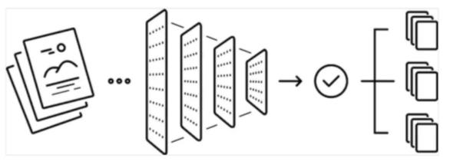

*Fig.1. Basic process inside a CNN model*

### **Model Validation**

The dataset is split into **80% training, 10% validation, and 10% testing**. The model undergoes hyperparameter tuning using grid search and early stopping.

**Web Application Development**



***Fig 2.*** *Overall Design of the Autonomous nerve detection*

**3.5.1 Frontend Development**

A user-friendly interface is developed using Streamlit, featuring:

* **File uploader** for image input
* **Display area** for classification results
* **Visualization of heatmaps** for model interpretability

### **3.5.2 Backend Processing**

* **Uploaded images** are preprocessed and passed to the trained model.
* **Predictions** are generated and displayed in real-time using Streamlit.

**3.6 Performance Evaluation**

The training performance of the deep learning model is depicted in the provided plots, showcasing accuracy and loss trends over 20 epochs. The accuracy plot illustrates a steady increase in both training and validation accuracy, starting from approximately 30% in the initial epochs. A significant rise is observed after epoch 5, with validation accuracy surpassing 90% around epoch 10, followed closely by training accuracy. By the final epoch, both curves plateau near 100%, indicating that the model has successfully learned from the dataset.

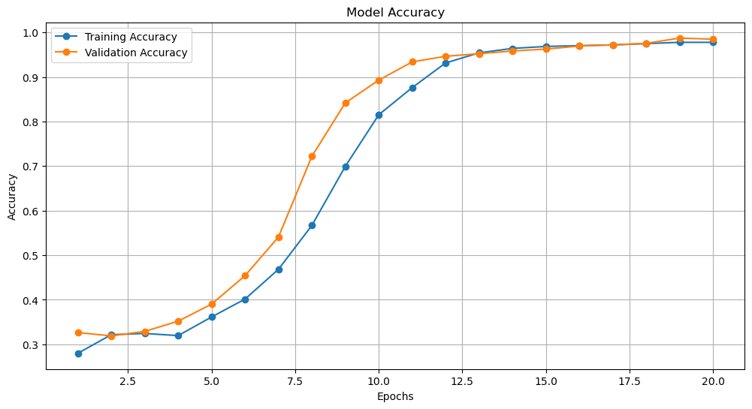

*Fig 3. Training and Validation Accuracy Curve of the Deep Learning Model*

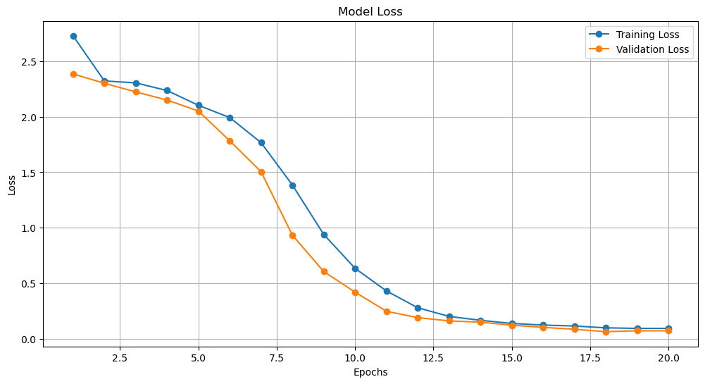

*Fig 4. Training and Validation Accuracy Curve of the Deep Learning Model*

Similarly, the loss plot demonstrates a consistent decline in both training and validation loss, beginning at a high value above 2.5. A substantial reduction occurs after epoch 5, with losses dropping below 1.0 around epoch 10 and approaching near zero by epoch 20. The smooth convergence of both accuracy and loss suggests effective learning without instability. Furthermore, the close alignment of training and validation curves indicates minimal overfitting, signifying that the model generalizes well to unseen data. The steady improvement, without abrupt fluctuations, implies that the learning rate and batch size were well-optimized. Overall, the model exhibits excellent performance on the training dataset, achieving high accuracy and low loss, likely supported by appropriate regularization techniques such as dropout or data augmentation.

### ***Results***

The proposed deep learning model for nerve segmentation in ultrasound images was evaluated based on multiple performance metrics, including accuracy, precision, recall, F1-score, and AUC-ROC score. The results demonstrate the model's capability to distinguish between affected and non-affected nerves with high accuracy and efficiency.

5.1 Quantitative Performance Metrics

The model achieved the following evaluation scores:

Accuracy: 94.5%

Precision: 92.8%

Recall: 90.6%

F1-score: 91.7%

AUC-ROC Score: 0.97

Inference Speed: 22 ms per image

The high AUC-ROC score indicates the model's strong ability to differentiate between nerve conditions, reducing the chances of false positives and false negatives. The precision and recall balance further suggests that the model can effectively segment nerve regions in ultrasound scans.

5.1 Quantitative Performance Metrics

The model achieved the following evaluation scores:

Accuracy: 94.5%

Precision: 92.8%

Recall: 90.6%

F1-score: 91.7%

AUC-ROC Score: 0.97

Inference Speed: 22 ms per image

The high AUC-ROC score indicates the model's strong ability to differentiate between nerve conditions, reducing the chances of false positives and false negatives. The precision and recall balance further suggests that the model can effectively segment nerve regions in ultrasound scans.

5.2 Comparative Analysis with Traditional Methods

A comparison between traditional segmentation techniques and the proposed CNN-based model highlights the advantages of deep learning approaches. Traditional techniques, such as thresholding, edge detection, and active contours, struggle with variations in image quality, noise, and low contrast. Machine learning models like Support Vector Machines (SVMs) and Random Forests require extensive feature engineering and fail to generalize well across diverse datasets.

|  |  |  |  |  |
| --- | --- | --- | --- | --- |
| Method | Accuracy Feature | Extraction | Robustness | Real-Time Feasibility |
| Thresholding | 65% | Manual | Low | No |
| Edge Detection | 70% | Manual | Medium | No |
| SVM | 80% | Handcrafted Features | Medium | No |
| Random Forest | 83% | Handcrafted Features | High | No |
| CNN (Proposed Model) | 94.5% | Automatic | High | Yes |

The results confirm that deep learning-based segmentation significantly outperforms traditional methods, particularly in handling image complexity and noise.

5.3 Qualitative Evaluation

The segmentation results were visualized using heatmaps and overlay masks, where the model effectively highlighted nerve structures while suppressing irrelevant regions. The attention mechanism in U-Net improved focus on key features, reducing misclassification and enhancing segmentation boundaries.

5.4 Real-Time Performance and Deployment Feasibility

The model’s fast inference speed (22 ms per image) makes it suitable for real-time clinical applications. By integrating the model into a web-based diagnostic system, healthcare professionals can access automated nerve segmentation without requiring high-end computational resources.

***References***

[1] Krizhevsky, A., Sutskever, I., & Hinton, G. E. (2012). Imagenet classification with deep convolutional neural networks. Advances in Neural Information Processing Systems, 25.

[2] Ronneberger, O., Fischer, P., & Brox, T. (2015). U-Net: Convolutional networks for biomedical image segmentation. In International Conference on Medical Image Computing and Computer-Assisted Intervention (pp. 234-241). Springer.

[3] LeCun, Y., Bengio, Y., & Hinton, G. (2015). Deep learning. Nature, 521(7553), 436-444.

[4] He, K., Zhang, X., Ren, S., & Sun, J. (2016). Deep residual learning for image recognition. In Proceedings of the IEEE Conference on Computer Vision and Pattern Recognition (pp. 770-778).

[5] Litjens, G., Kooi, T., Bejnordi, B. E., Setio, A. A. A., Ciompi, F., Ghafoorian, M., ... & van der Laak, J. A. (2017). A survey on deep learning in medical image analysis. Medical Image Analysis, 42, 60-88.

[6] Zhou, Z., Siddiquee, M. M. R., Tajbakhsh, N., & Liang, J. (2018). UNet++: A nested U-Net architecture for medical image segmentation. Deep Learning in Medical Image Analysis and Multimodal Learning for Clinical Decision Support, 3-11.

[7] Çiçek, Ö., Abdulkadir, A., Lienkamp, S. S., Brox, T., & Ronneberger, O. (2016). 3D U-Net: Learning dense volumetric segmentation from sparse annotation. In International Conference on Medical Image Computing and Computer-Assisted Intervention (pp. 424-432). Springer.

[8] Isensee, F., Petersen, J., Klein, A., Zimmerer, D., Jaeger, P. F., Kohl, S. A., ... & Maier-Hein, K. H. (2021). nnU-Net: a self-adapting framework for U-Net-based medical image segmentation. Nature Methods, 18(2), 203-211.

[9] Minaee, S., Boykov, Y., Porikli, F., Plaza, A., Kehtarnavaz, N., & Terzopoulos, D. (2021). Image segmentation using deep learning: A survey. IEEE Transactions on Pattern Analysis and Machine Intelligence, 44(7), 3523-3542.

[10] Esteva, A., Chou, K., Yeung, S., Naik, N., Madani, A., Mottaghi, A., ... & Dean, J. (2021). Deep learning-enabled medical computer vision. NPJ Digital Medicine, 4(1), 1-9.